Experiment No: 4

Title: Real-Time Case Study: ATM Card PIN Verification Using JavaScript Functions (Palindrome Checker). Software/Tools Required: Visual Studio Code (or any text editor), Web Browser.

Theory: 1. Introduction to JavaScript Functions A function in JavaScript is a reusable block of code designed to perform a particular task. Functions allow developers to write modular, maintainable, and DRY (Don't Repeat Yourself) code. In modern JavaScript, functions can be defined and executed in several ways, each serving different architectural purposes.
2. Types of Function Definitions In this case study, three distinct methods of defining functions are implemented:
- Function Declaration: Defined using the standard function keyword followed by a name. These functions are hoisted to the top of their current scope, meaning they can be called before they appear in the code structure.
  - Usage in Experiment: Used for the main verifyATM() execution block as it acts as the primary event handler triggered by the user interface.
- Function Expression: A function that is assigned to a variable. These can be named or anonymous and are not hoisted, meaning they can only be executed after the interpreter reaches that line of code.
  - Usage in Experiment: Used to define the reversePin logic, ensuring the function is securely bound to a constant variable.
- Arrow Function: Introduced in ES6, arrow functions (=>) provide a more concise syntax for writing function expressions. They do not bind their own this context, making them highly efficient for callbacks and inline operations.
  - Usage in Experiment: Used for the checkPalindrome comparison logic to quickly evaluate if the original and reversed strings match.
3. Concept of Scope Scope determines the accessibility and visibility of variables across different parts of the code.
- Global Scope: Variables declared outside any function are globally accessible, which can lead to data manipulation risks if not handled properly.
- Local / Block Scope: Variables declared inside a function or a block (using let and const) are only accessible within that specific boundary. In this ATM system, variables like the entered PIN and reversed PIN are strictly kept within local scope to ensure security and prevent data leakage.
4. Lexical Closures for Data Privacy A closure is a fundamental JavaScript concept where an inner function has access to the outer (enclosing) function’s variables, even after the outer function has finished executing. Closures are heavily used in functional programming to create private variables and stateful functions.
- Implementation in ATM Case Study: To track the number of PIN verification attempts, a global counter is insecure. Instead, a closure (secureATMSession) is created to encapsulate the attempts variable. The inner function logAttempt() retains access to this variable, allowing the application to update the UI securely without exposing the core data to the global scope window.
5. Exception Handling (try...catch) To ensure the ATM application does not crash upon receiving unexpected input, error handling is implemented using the try...catch statement.
- The try block tests the user's input against specific conditions (e.g., checking if the PIN is blank or contains alphabetical characters instead of numbers).
- If an invalid condition is met, a custom exception is generated using the throw keyword.
- The catch block intercepts this error and gracefully displays a warning message to the user, maintaining the integrity and continuous operation of the application.

Output:

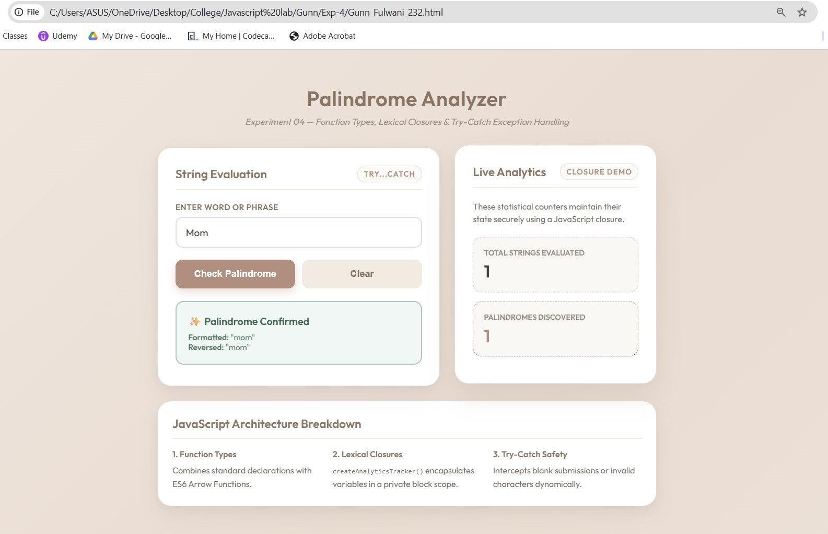
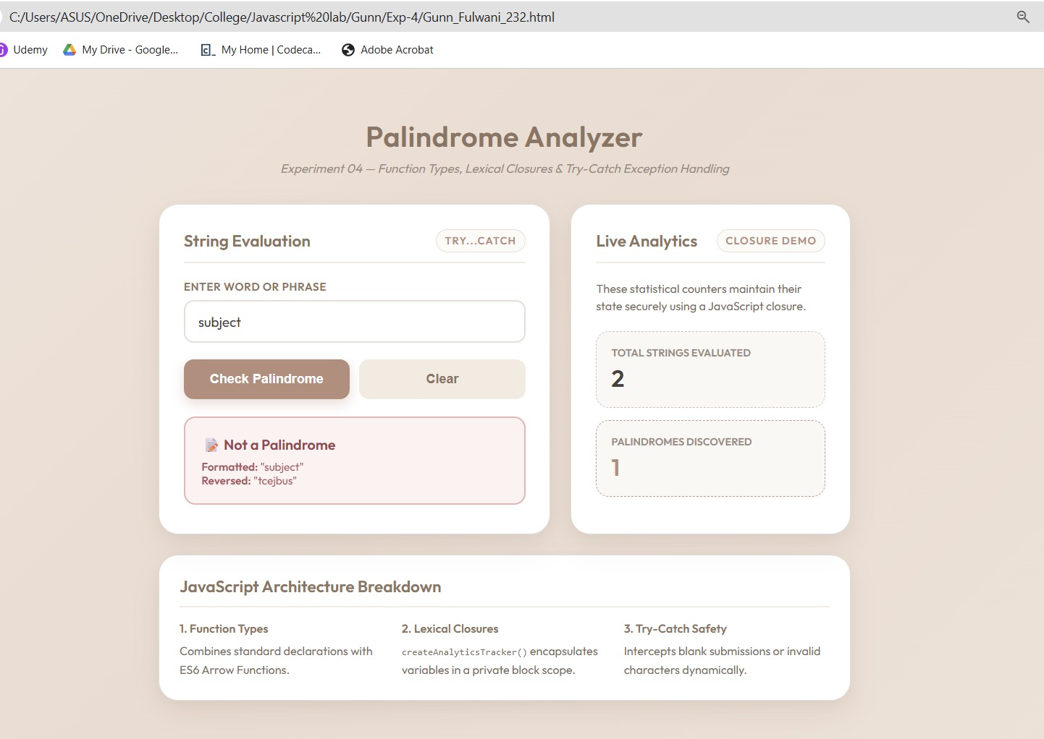
Result/Conclusion: The experiment was successfully completed. The ATM Card PIN Verification system was implemented using three distinct JavaScript function types: declarations, expressions, and arrow functions. Furthermore, a secure lexical closure was successfully integrated to track user attempts independently of the global scope. Form validation and robust error handling were achieved using a try...catch block, resulting in a secure, dynamic, and aesthetic web interface.

